**Assignment 6.2**

**Problem​ ​Statement​ ​1:**

**Find the variance for the following set of data representing trees in California (heights in**

**feet):**

**3,​ ​21,​ ​98,​ ​203,​ ​17,​ ​9**

**Note:​ ​Solution​ ​submitted​ ​via​ ​github​ ​must​ ​contain​ ​all​ ​the​ ​detailed​ ​steps.**

**Ans: We have solved the statistics problem on white paper and adding image on the assignment.**

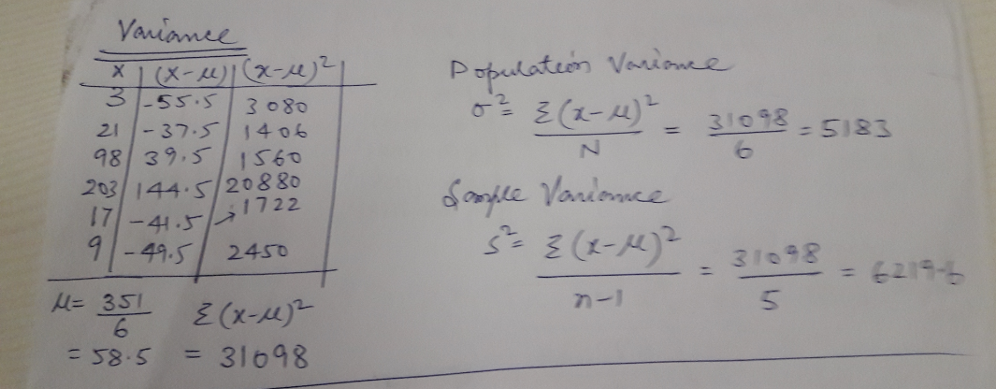

**Population Variance = 5183**

**Sample Variance = 6219.6**